Good health and well being

Ayush Fartyal

HuageraJoe+oer+dMageeecblfoodsectip





Huoget-.aa'Wa'bereevery@esceeesesacaé?zrJsfood







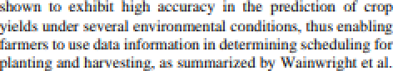

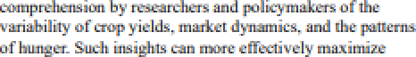

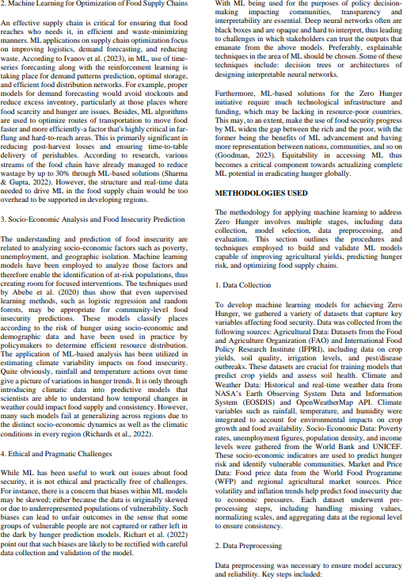

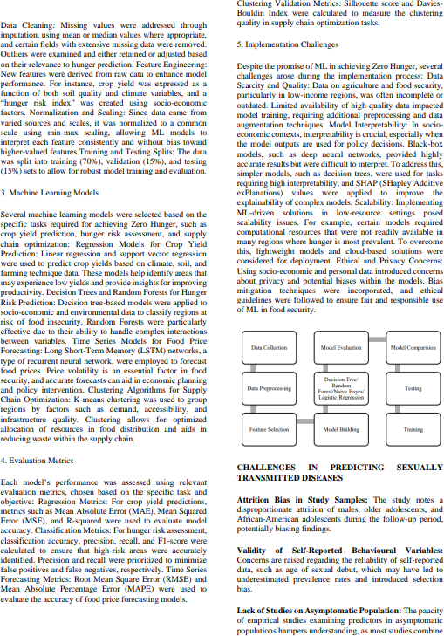

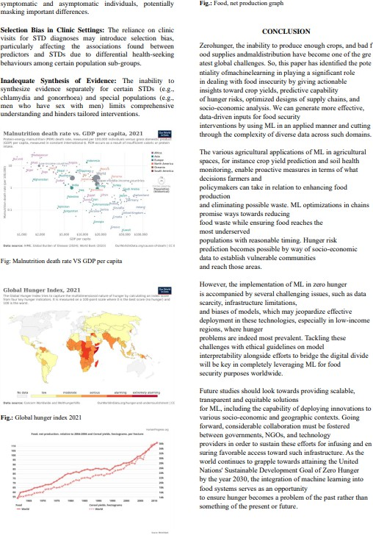

 









Ueă+g Soóc-Eezatœtîz aadEavăatoteoudŁŁaa• A btæbòe Leeœă+g A K•aŁow+YiniØCîoãa/Foo<fSu<srï¿.







